Q1:

‘c’, ‘c-c’, ‘c-c-c’, ‘c-c-c-c’ are frequent

Q2:

(1):

Step1:

Rank(u0)=1/3

Rank(u1)=2/4

Rank(u2)=1/4

Rank(u3)=2/2

Rank(u4)=2/2

Rank(u5)=1/2

Rank(u6)=2/1

Rank(u7)=3/1

Rank(u8)=3/1

Hence, u2 is selected as the root node.

Step2:

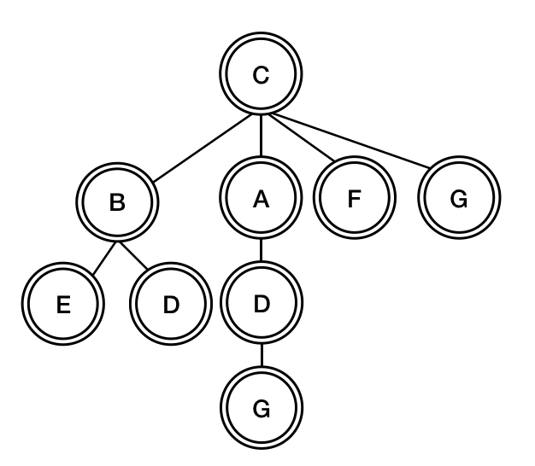

(2):

core-set:

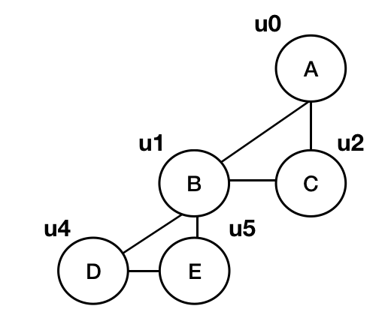

forest-set:

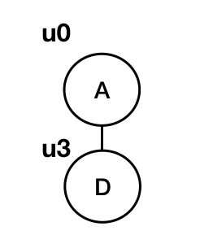

leaf-set:

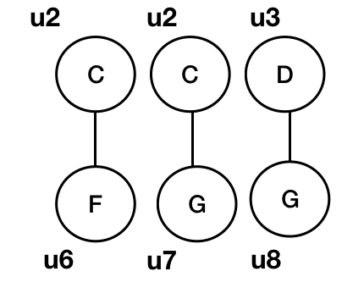

Q3:

Choose v3 as activated seed can generate largest influence spreads.

w(v3)=1, w(v2)=0.4, w(v7)=0.3, w(v9)=0.5, w(v0)=0.12, w(v6)=0.08

w(v1)=0.06, w(v4)=0.3, w(v8)=0.05, w(v5)=0.024

so the maximum sum is 2.824